MODULE 3

VIDEO LINK: https://vimeo.com/1055709405/ac5fd275c6

SCRIPTS
- Create a sphere that moves back and forth on a line by stopping at the end points and moving with maximum velocity on the mid-point using CoppeliaSim APIs.
function sysCall_init()
sim = require('sim')
sphereHandle = sim.getObject('..')

-- Get initial position of the sphere in world coordinates
local initPos = sim.getObjectPosition(sphereHandle, -1)

-- Define endpoints relative to the initial position:
local offset = 0.5
endpoints = {
{initPos[1] - offset, initPos[2], initPos[3]}, -- left endpoint
{initPos[1] + offset, initPos[2], initPos[3]}, -- right endpoint
}
end

function sysCall_thread()
-- Ruckig motion profile
local maxVel = {0.5, 0.5, 0.5, 0.1}
local maxAccel = {0.2, 0.2, 0.2, 0.1}
local maxJerk = {0.1, 0.1, 0.1, 0.1}

local i = 1
while not sim.getSimulationStopping() do
local targetPos = endpoints[i]
local params = {
object = sphereHandle,
targetPose = {targetPos[1], targetPos[2], targetPos[3], 0,0,0,1},
maxVel = maxVel,
maxAccel = maxAccel,
maxJerk = maxJerk,
flags = 0,
}

sim.moveToPose(params)
sim.wait(1) -- pause at endpoints
i = (i == 1) and 2 or 1
end
end

- Use the CoppeliaSim model database UR5 and program it to move to three different poses by commanding its joint angles.
sim = require('sim')

function moveToConfig(handles, maxVel, maxAccel, maxJerk, targetConf)
local params = {
joints = handles,
targetPos = targetConf,
maxVel = maxVel,
maxAccel = maxAccel,
maxJerk = maxJerk,
}
sim.moveToConfig(params)
end

function sysCall_thread()
local jointHandles = {}
for i = 1, 6 do
jointHandles[i] = sim.getObject('../joint', {index = i - 1})
end

local vel = 180
local accel = 40
local jerk = 80
local maxVel = {vel * math.pi / 180, vel * math.pi / 180, vel * math.pi / 180, vel * math.pi / 180, vel * math.pi / 180, vel * math.pi / 180}
local maxAccel = {accel * math.pi / 180, accel * math.pi / 180, accel * math.pi / 180, accel * math.pi / 180, accel * math.pi / 180, accel * math.pi / 180}
local maxJerk = {jerk * math.pi / 180, jerk * math.pi / 180, jerk * math.pi / 180, jerk * math.pi / 180, jerk * math.pi / 180, jerk * math.pi / 180}

local poses = {
-- Pose 1
{90 * math.pi / 180, 90 * math.pi / 180, -90 * math.pi / 180, 90 * math.pi / 180, 90 * math.pi / 180, 90 * math.pi / 180},
-- Pose 2
{-90 * math.pi / 180, 45 * math.pi / 180, 90 * math.pi / 180, 135 * math.pi / 180, 90 * math.pi / 180, 90 * math.pi / 180},
-- Pose 3
{30 * math.pi / 180, -90 * math.pi / 180, 45 * math.pi / 180, 120 * math.pi / 180, -60 * math.pi / 180, 0},
-- Pose 4
{0, 0, 0, 0, 0, 0}
}
while not sim.getSimulationStopping() do
for i, pose in ipairs(poses) do
moveToConfig(jointHandles, maxVel, maxAccel, maxJerk, pose)
sim.wait(2) -- Wait before switching to next pose
end
end
end

Starting Position:

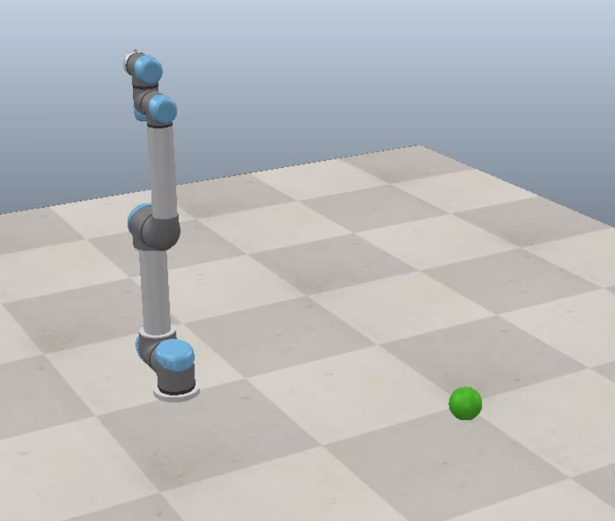

UR5 at first position while ball moving to first end pos
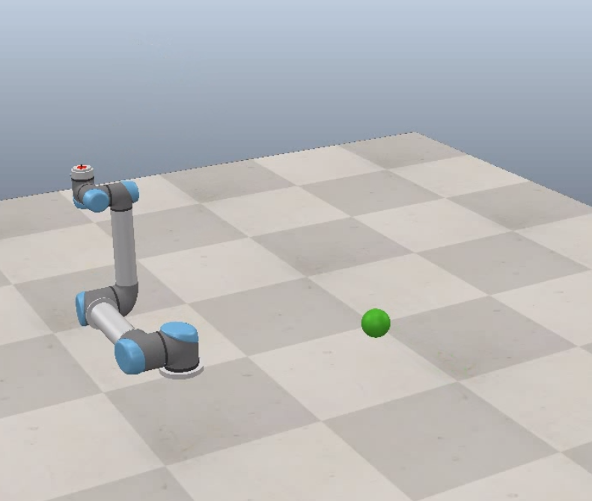

UR5 moves to second pos while ball rapidly passed through it’s center point and decelerates to its other endpoint

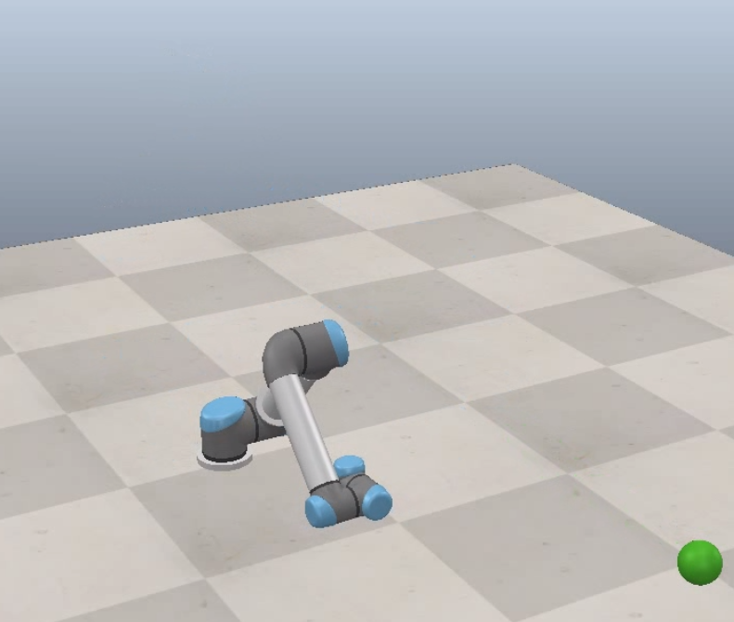

UR5 gets to third pos while sphere is moving back to other endpoint (captured almost 75% of the way there)
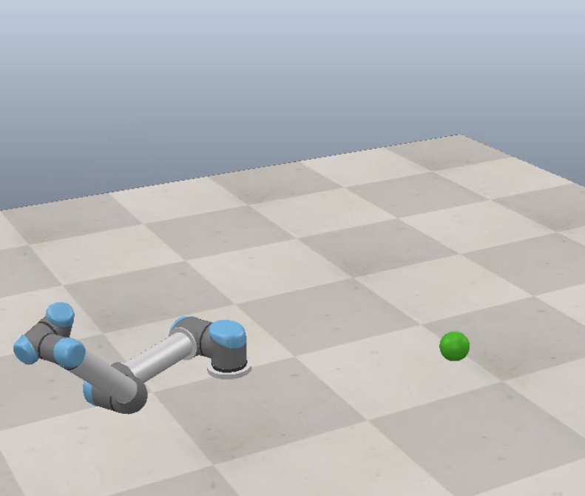

UR5 resets back to original pos and ball continues to move to other endpoint

